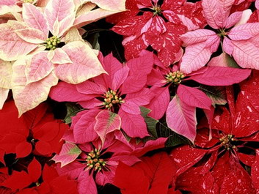

**POINSETTIA SALE**

**Strawberry Crest H.S. Musical Chargers**

**Holiday Fundraiser**

***Nothing signals Christmas like the beautiful blooms of a poinsettia!***

**~ ORDER TODAY ~**

**6" plants (5-7 red & white blooms) $10.00**

**8" plants (7-9 red & white blooms) $15.00**  
**10" plants (9+ red blooms) $20.00**

**Poinsettias are perfect for the season and can be used in many ways:**

* home, office, garden, lobby, restaurant/club decor
* gifts for friends, family or colleagues
* hostess gifts
* centerpieces
* delivering a "Gift Card" to that special someone - *attach your card to a beautiful bloom*
* "thinking of you this season" gifts - *brighten the day of a neighbor, a senior or one less fortunate*

Orders will be accepted through **Friday, November 20.**    
Poinsettias will be available for pickup on the   
**Thursday, December 5, 2019.**

**Please submit payment when ordering.**

**Make checks payable to SCHS Band Boosters.**

***Thank you in advance for your support!***